1. **PURPOSE:**

To describe the procedure for Operation and calibration of HPLC system in Laboratory.

1. **SCOPE:**

The procedure applicable to the Operation and calibration of HPLC system.

Make : Agilent

Model No: 1120 Compact LC

ID No.: DIPL/QC/INS/HPLC/002

1. **RESPONSIBILITY:**
   1. Analyst-QC is responsible to follow this SOP.
   2. Head-QC/Designee is responsible for ensuring implementation of this SOP.
   3. Head-QA/Designee is responsible for monitoring overall compliance of this SOP.
2. **DEFINITIONS:**

Nil

1. **PROCEDURE:**
   1. **Operation:**
      1. Clean the instrument with a clean cotton cloth.
      2. Prepare mobile phase as required, as desire in the analytical method and filter through 0.45 Microns membrane filter. Place the mobile phase in reservoir and degas it by pacing in an micron membrane filter. Place the mobile phase in reservoir and degas it by placing in an ultrasonic both.
      3. Note: Do not use mobile which contains buffer which is 2days older from the date of preparation and the one without buffer after 6 days filtration should be required. From date of preparation.
      4. Keep the reservoirs including that containing washing solvent and mobile phase in solvent cabinet on top of the system and insert tubing in all reservoirs
      5. Install the column specified in the analytical method and fix with the column clip
      6. Switch ON the power of Instrument and computer.
      7. Double Click “Lab monitor &Diagnostic “and click the “Lab Monitor Management “and click non start monitoring.

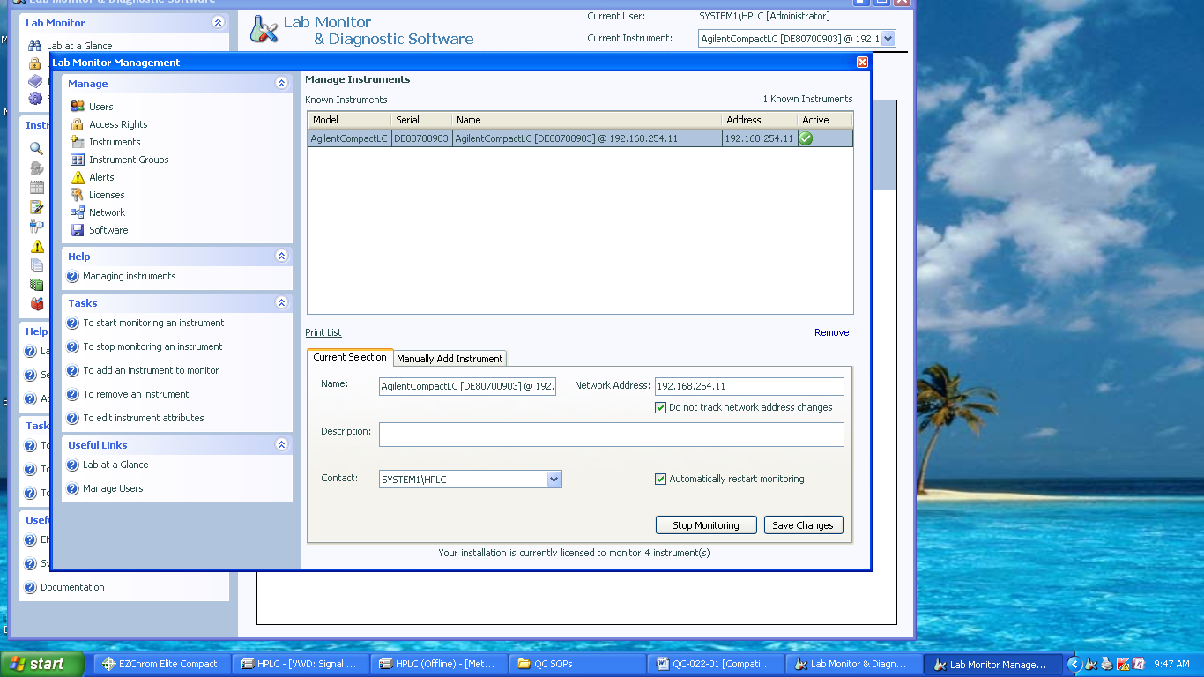

* + 1. It activates in to green colour.



* + 1. Close the LMM window and minimize the LMD software.
    2. Start ‘Ezcrom Elite’ Software by double clicking the Ezcrom icon on the desktop

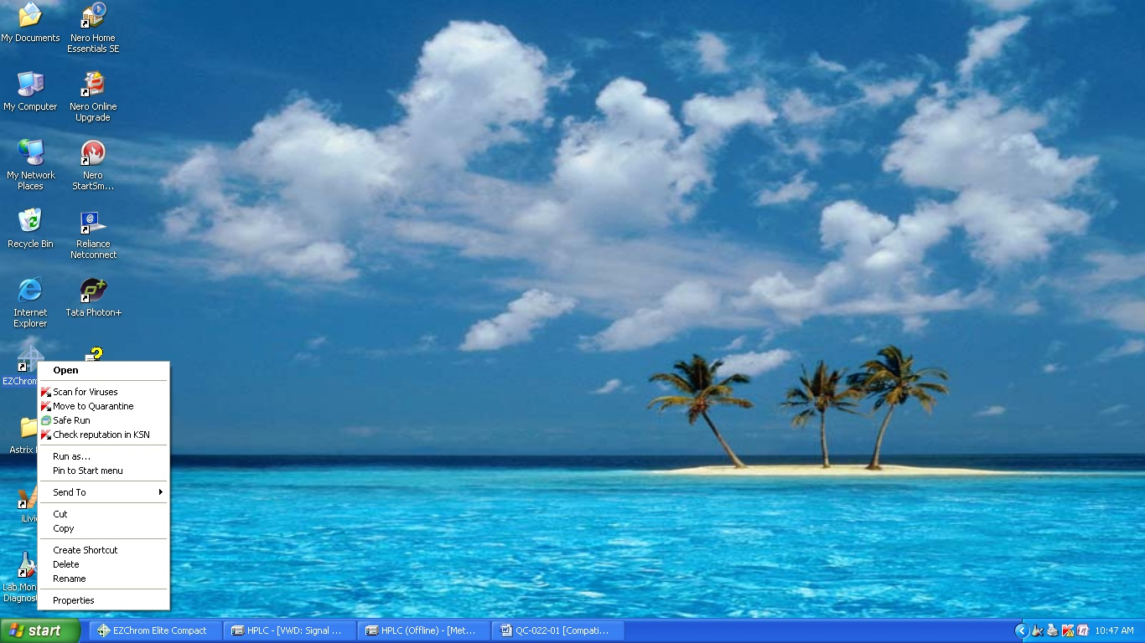

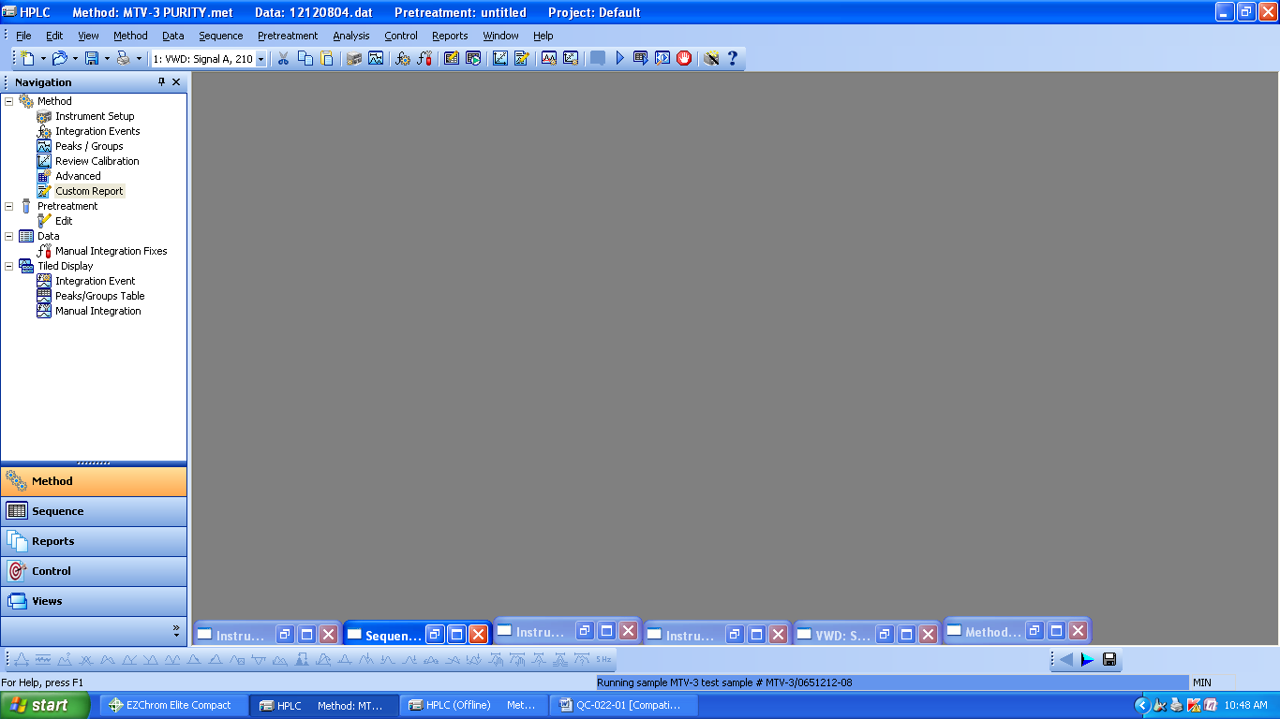

* + 1. To switch on the modules of the HPLC like pump & Detector .Go to control and click on Instrument status

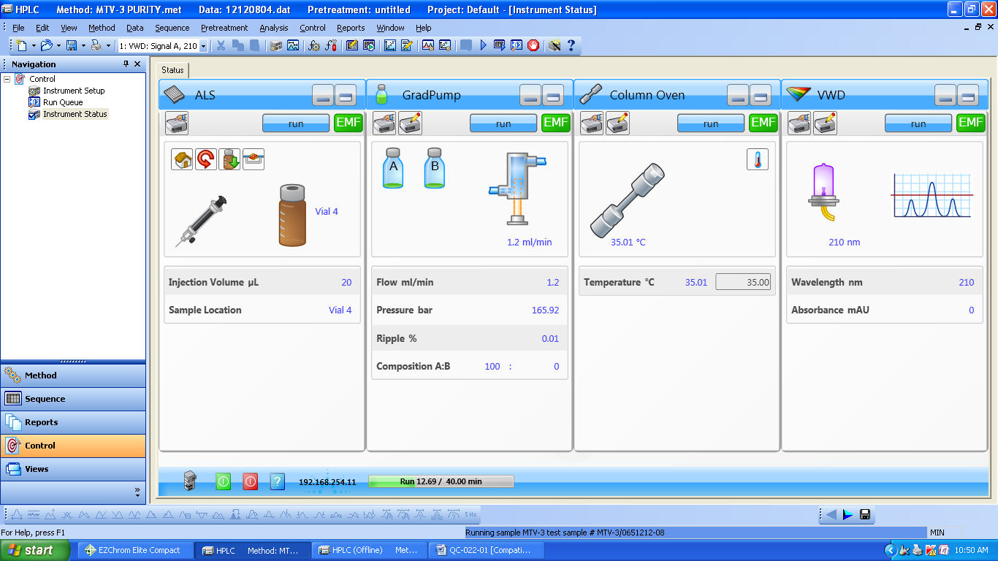

* + 1. Single click to on the both modules .Before starting any analysis purge the system with Suitable solvent by using 5 ml flow rate .And close the purge valve by setting the flow 1 ml and flush the system with mobile phase. For about 10-15 minutes with column. For the column stabilization
    2. A navigation pane or method is displayed at the left side of the instruments windows. This View enables to quickly switch between the measure function of the instrument window.

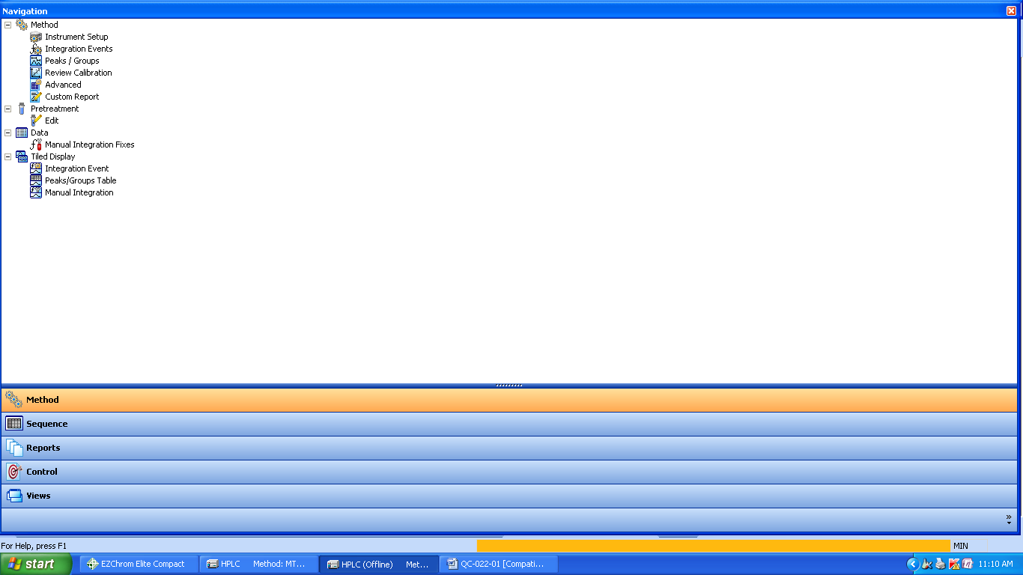

* + 1. **Method**: Go to “Method” menu and create modify the new method or appropriate method From the method list.
    2. Ensure that method parameters are set as per the described standard in the test procedure.
    3. Set the instrument parameter i.e Instrument setup-flow rate, injection volume, wavelength
    4. Save the method after completing the method parameter from the file menu. Followed by Method and click save Aa.
    5. Go to control and click on download method
    6. Sequence: File > Sequence >New (Create new sequence)

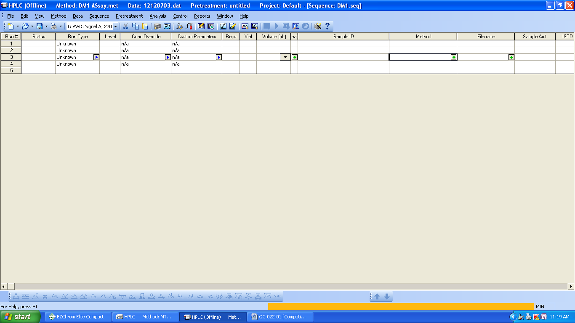

* + 1. Enter vial No., method name, data file name, injection volume, sample ID
    2. Go to file > Sequence >save as .if any change is existed sequence then save it to open sequence File Go to file > Sequence >open
    3. To set up for single acquisition click on Single run
    4. To set up for Sequence acquisition click on Sequence run.

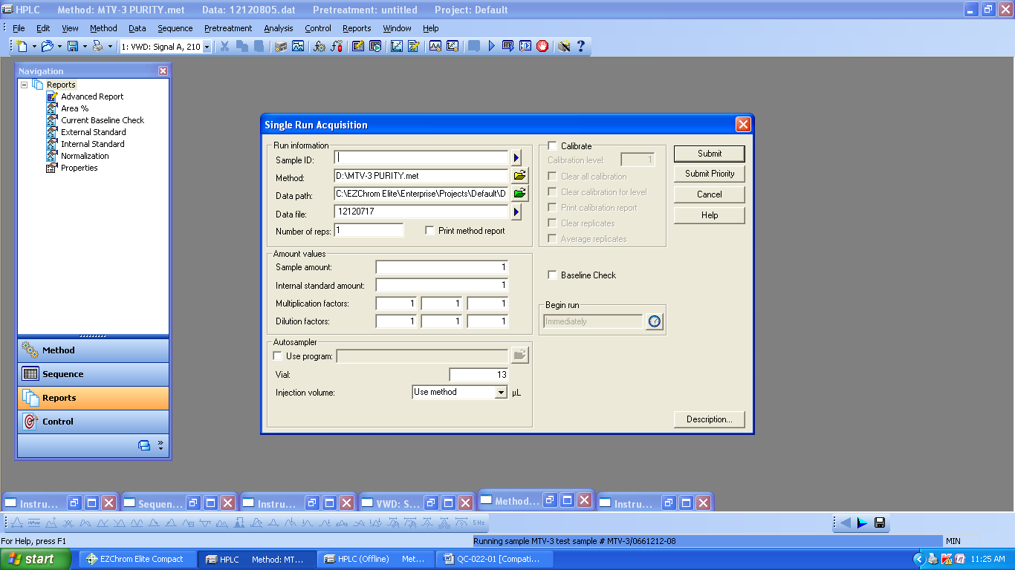

* + 1. Enter the sample ID & Data file name. And click start to run the analysis.
    2. Instrument checks (equilibrating method) system is ready for analysis after that instrument shows “Waiting for Trigger” than automatically it collects the sample from injection vial.
    3. **INTEGRATION TOOL**: To Click the proper suitable integration tool. Enter the desired Integration parameters like slope sensitivity, peak width, integration ON, OFF, base line at Valley etc. and requirement for method.

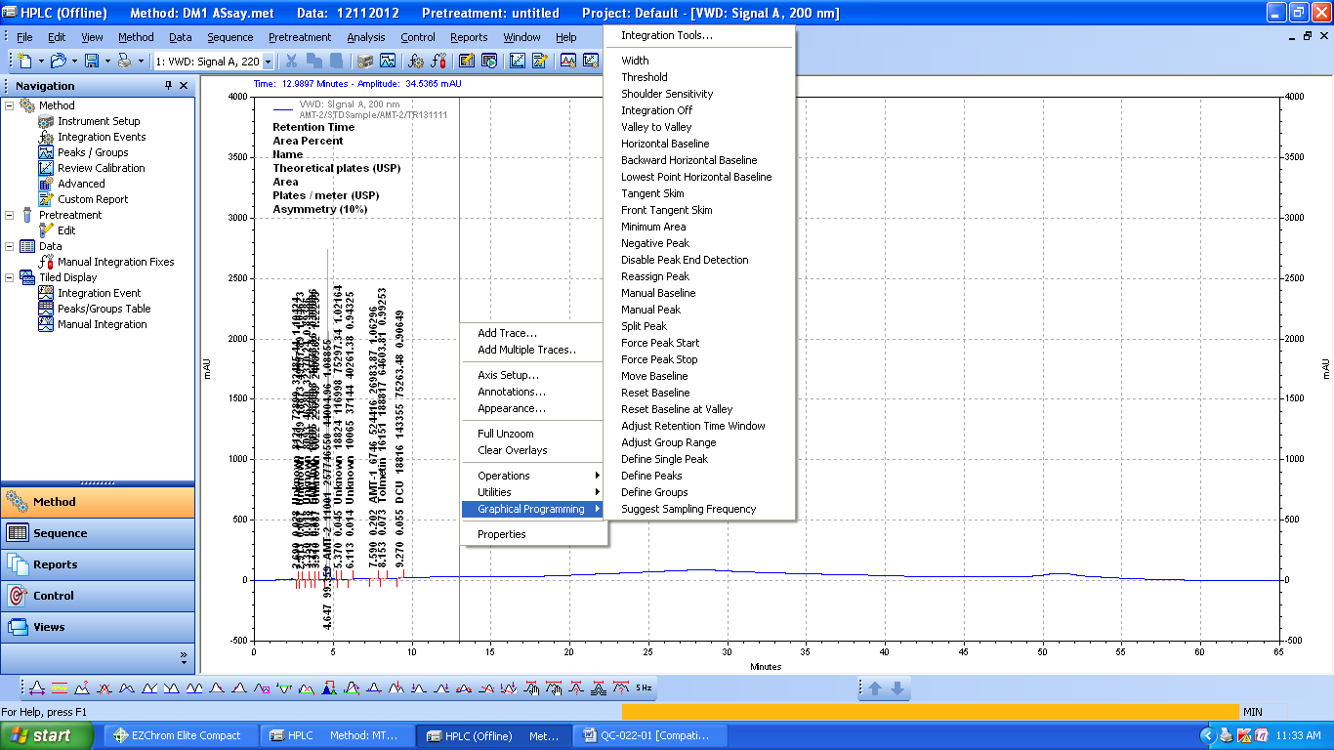

* + 1. To describe the all tools in Ezchrom software

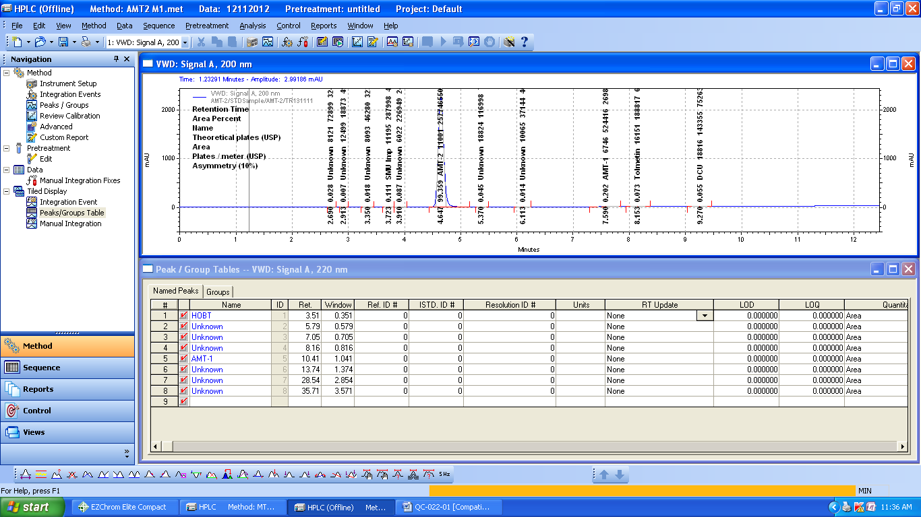

* + 1. This data is being acquired: it is also displayed in a chromatogram window. You can Change the Appearance of the chromatogram and select annotations fonts, and labeling Utilities are available to Print the current window view, copy it to a clipboard, or save it in a file.

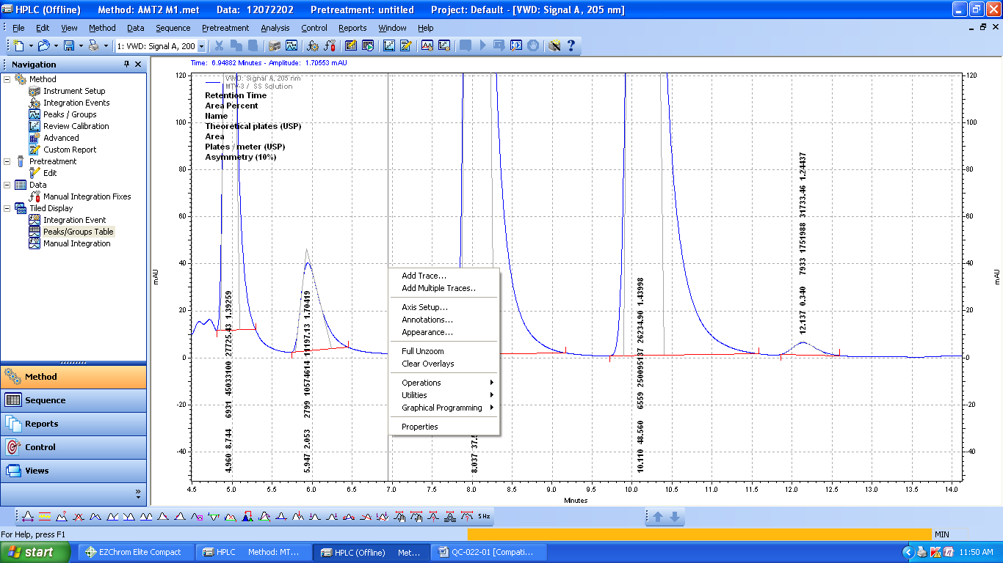

* + 1. Click on an Available Annotation. When an annotation is highlighted, you can add it to the Annotations to be shown by clicking the Green arrow key (pointing to the right). This can also be Done by double-clicking the selection

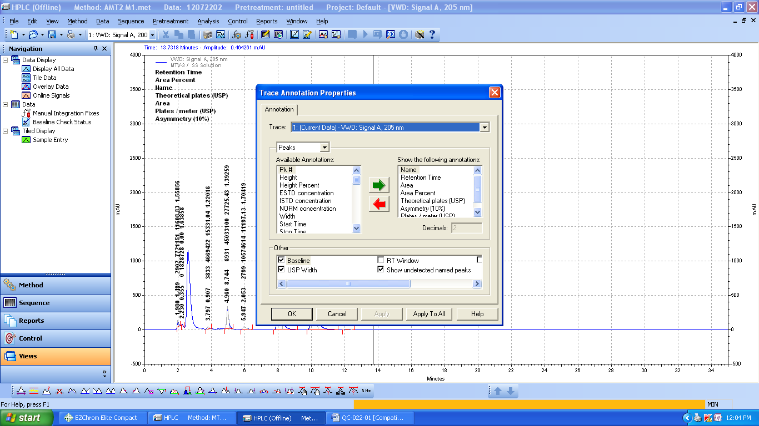

* + 1. You can change the appearance of the trace (line type, color, etc) from the Appearance tab in the Properties box .Click on this tab to display the Appearance tab dialog.

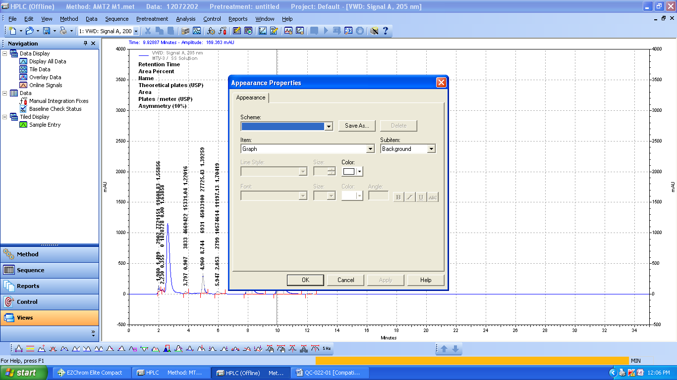

* + 1. Go to “method “and click on custom report. Right click on custom report file to give “print Preview” and click on print to get print out.
    2. Wash the column with the HPLC grade water & Solvent.
  1. **Calibration:**
     1. Instrument should be calibrated once in 4 months with ± 7 days of the due date.
     2. **Flow Rate Calibration:**
        1. Ensure that the solvent reservoir contains sufficient HPLC water and suspend the suction filter In it so that it dips in water.
        2. Before starting the calibration purge the system with water to remove air bubbles from the flow Line.
        3. Install the restrictor capillary /union and allow about 15 minute’s equilibration the system with Water at the flow rate 1.0 ml /min with equal mixing A, B channels
        4. Place a previously weighed 10 ml volumetric flask to receive the water coming out of the system
        5. Set the flow collects the water from the column inlet exactly for 2min as measured by a stop watch And weigh the volumetric flask.
        6. Take two readings and note down the weights of water collected
        7. Repeat the operation for flow at 1.0ml/min for 10 min, and at 2.0 ml/min for 5min record the Observations
        8. Calculate actual flow and RSD for duplicate measurement for each flow rate

**Note:** *density of water at 25ºC is 0.99602gr

Reference IP-2007 of Volumne-1 Page 165

* + - 1. **Acceptance Criteria:**

|  |  |
| --- | --- |
| **Set flow ml/min** | **Acceptance criteria** |
| 0.50 | 0.49-0.51 |
| 1.0 | 0.98-1.02 |
| 2.00 | 1.96-2.04 |

* + 1. **Gradient Composition & Delay Volume**
* **Chromatographic Condition:**

|  |  |  |
| --- | --- | --- |
| Column | **:** | Restriction Capillary |
| Detector wavelength | **:** | 254nm |
| Injection volume | **:** | 20 µl |
| Flow rate | **:** | 2.0ml/minute |
| Runtime | **:** | 30 minutes |
| Mobile Phase | **:** | Mobile Phase-A: Analytical water  Mobile Phase-B:  0.3% v/v acetone in filtered analytical water  (1ml of acetone in 1000ml of water) |

Gradient Programme:

| **Time (min)** | **Mobile phase B percentage** |
| --- | --- |
| 0.01 | 0 |
| 2.00 | 0 |
| 2.01 | 10 |
| 8.00 | 10 |
| 8.01 | 50 |
| 13.00 | 50 |
| 13.01 | 90 |
| 18.00 | 90 |
| 18.01 | 100 |
| 23.00 | 100 |
| 23.01 | 0 |
| 30.00 | 0 |

* **Procedure:**

Open the drain valves and purge the flow lines of both pumps. Equilibrate the column with initial concentration with above mentioned conditions and wait until the baseline is stable Adjust the baseline level to fit the full Scale of the integrator. Inject exactly 20 µL of mobile phase A and start the time program for gradient accuracy test.

Determine the signal level at 0% (B Con),10% (B Con), 50% (B Con), 90% (B Con) and 100% (B Con)

Calculate the actual B concentration level at 10% (B Con), 50% (B Con), 90% (B Con) Using 0% (B Con) and 100% (B Con).

* **Calculation:**

Calculate the actual B concentration level at 10**%**

Similarly calculate the actual B concentration level at 50% (B Con) and 90% (B Con) Follow the Procedure exactly using C&D channels instead of A&B.

* **Acceptance *Criteria:***

**For pump A&B**

At B concentration 10 %level actual concentration should be between 9.0% and 11.0%.

At B concentration 50% level actual concentration should be between 49.0% and 51.0%.

At B concentration 90% level actual concentration should be between 89.0% and 91.0%.

* + - 1. **Delay Volume:**
         1. It is the measure of liquid volume occupied by the system, use the same method as for gradient profile.
         2. Measure the delay volume from the gradient profile chart by noting the difference of actual change in absorbance and predicated change. For example ,in the gradient Programme, the change is given at 2.0 minutes , if the absorbance rise is observed at 3.0 minutes ,the delay volume is 1.0 ml
         3. **Acceptance Criteria:**

Delay volume of the system should be not more than 2.0 ml

* + 1. **System Precision & Carry over:** 
       1. Prepare the required standard solution and set the chromatographic condition as mention below
       2. Standard preparation: weigh accurately 100±2mg Caffeine AR in a100 ml volumetric flask dissolve in 25 ml HPLC Methanol and make up volume with the same.
       3. Transfer 5ml of above solution in another 100 ml volumetric flask and make up the volume with methanol (50ppm )
       4. HPLC Conditions

|  |  |
| --- | --- |
| Column | Restrictor capillary 2m x 0.12 mm ID |
| Mobile Phase | Methanol : water (70:30) |
| Flow rate ml/min | 1ml/min |
| Wave length | 272nm |
| Run time | 5minutes |

* + - 1. Apply the sequence of blank, six replicate injections with 50 ppm Caffeine solution in methanol and blank After complete the runs measure peak retention time and area Last blank in sequence shall be used to measure carryover of auto sampler
      2. Calculate the % RSD for each and record the observation in annexure-1

|  |  |
| --- | --- |
| **% RSD for retention time** | **NMT 1.0%** |
| **% RSD for Area** | **NMT 2.0%** |
| **%Carry over** | **NMT 5.0%** |

* + 1. **Detector linearity:**
       1. **Standard preparation :**
          1. **Solution A:** weigh accurately 100±2mg Caffeine AR in a100 ml volumetric flask, dissolve in 25 ml HPLC Methanol and make up volume with the same
          2. **50ppm**: Pipette 5ml of solution –A in 100 ml volumetric flask and make up with methanol
          3. **5ppm**: Pipette 2.5ml of solution –A in 100 ml volumetric flask and make up with methanol
          4. **10ppm**: Pipette 10ml of 50ppm solution in 50 ml volumetric flask and make up with Methanol
          5. **5ppm**: Pipette 5ml of 50ppm solution in 50 ml volumetric flask and make up with methanol
          6. **1ppm**: Pipette 1ml of 50ppm solution in 50 ml volumetric flask and make up with methanol
       2. Set the chromatographic condition as mentioned below.

|  |  |
| --- | --- |
| Column | Restrictor capillary 2m x 0.12 mm ID |
| Mobile Phase | Methanol :water (70:30) |
| Flow rate ml/min | 1ml/min |
| Wave length | 272nm |
| Run time | 5minutes |

* + - 1. Inject the solution in sequence of 1 ppm,5ppm,10ppm,25 ppm and 50ppm
      2. After the completion of each run measure are of caffeine peak and record the observation in annexure-1. Calculate the co-relation coefficient of the peak areas.

|  |  |
| --- | --- |
| **Acceptance criteria:** | |
| **Correlation coefficient** | **NLT 0.999** |

* + 1. **Wave length Accuracy :**
       1. UV wave lengths Accuracy check using Maximum & minimum absorbance wave length of caffeine obtain with 50 ppm solution.
       2. Solution-A: weigh accurately 100±2mg Caffeine AR in a100 ml volumetric flask ,dissolve in 25 ml HPLC Methanol and make up volume with the same.
       3. **50ppm**: Pipette 5ml of solution –A in 100 ml volumetric flask and make up with methanol.
       4. Chromatographic condition:

|  |  |
| --- | --- |
| Column | Restrictor capillary 2m x 0.12 mm ID |
| Mobile Phase | Methanol :water (70:30) |
| Flow rate ml/min | 1ml/min |
| Wave length | 200-210,240-250, and 268-278nm |
| Run time | 5minutes |

* + - 1. Increase the wave length setting from 200-210,240-250 and 268-278nm 1 nm increments and record chromatogram after 1 nm increment rise in annexure-1

|  |  |
| --- | --- |
| **Acceptance criteria:** | |
| **Maximum absorbance** | 271±2nm and 205 ±2nm |
| **Minimum absorbance** | 244±2nm |

* + 1. **Injector linearity:**
       1. **Standards Preparation:**
          1. **Solution A:** weigh accurately 100±2mg Caffeine AR in a100 ml volumetric flask, dissolve in 25 ml HPLC Methanol and make up volume with the same
          2. **50ppm**: Pipette 5ml of solution –A in 100 ml volumetric flask and make up with methanol
          3. **10ppm**: Pipette 10ml of 50 ppm solution in 100 ml volumetric flask and make up with Methanol
       2. Set the chromatographic condition as mentioned below. Inject 10ppm caffeine solution 5, 10, 20, 50, and 100 micro liter and record the Chromatograms. Calculate correlation coefficient of conc. Vs peak areas

|  |  |
| --- | --- |
| Column | Restrictor capillary 2m x 0.12 mm ID |
| Mobile Phase | Methanol :water (70:30) |
| Flow rate ml/min | 1ml/min |
| Wave length | 254nm |
| Run time | 5minutes |

* + - 1. **Acceptance criteria:**

|  |  |
| --- | --- |
| correlation coefficient | NLT 0.999 |

* + 1. **Column Oven Temperature :**
       1. The temperature of the column oven is to be determined using a calibrated thermometer at 25ºC, 40ºC, 50ºC, 60ºC , 70ºC either by internally or externally**.**
       2. **Acceptance Criteria:**

Not more than ±2ºC for set temperature.

* + 1. **Injection Volume Accuracy:**
       1. Fill the vial with HPLC water note down the weight and place in the sample tray at vial number-1.
       2. Methanol shall be used as above and create a sequence it get 10 injections with 50µL injection Volume and run time is 0.1 min and start sequence. After 10 injections remove the vial and weigh Again Calculate as give below:
       3. **Acceptance criteria:** ±1.0µl
  1. **Preventive maintenance** :
     1. Whenever system is under break-down or preventive maintenance of instrument is required to inform Service Engineer and out the label “Under maintenance’ or ‘Under breakdown’ on it
     2. Preventive maintenance shall be carried out by a trained Service Engineer of Supplier
     3. After completion of service record the fact of replacement of any major part of instrument.
     4. Calibrate the instrument after the maintenance is over.
     5. Remove the label mentioned in step 5.0

1. **FORMATS / ANNEXURE(S):**
   1. Instrument usage log book : QC048-FM088
   2. HPLC Calibration Record : QC022-FM056
2. **CHANGE HISTORY:**

| **Revision No.** | **Effective Date** | **Details of Revision** | **Ref CCF No.** |
| --- | --- | --- | --- |
| 00 | 01.09.2010 | New SOP Introduced | -- |
| 01 | 07.11.2012 | 1. Change Acceptance Criteria in Gradient Composition & Delay time. 2. Incorporate Minimum absorbance in wave length accuracy test. | -- |
| 02 | 01.06.2014 | 1. Gradient GVP Acceptance criteria Change ±4% to ±2 2. Formats are the part of SOP. So prepared separately. | -- |
| 03 | 01.01.2017 | 1. SOP format changed make to in line with SOP-QA-001-04. 2. Gradient program modified. 3. Detector and Injector linearity correlation co-efficient value changed from 0.99 to 0.999. 4. Altogether procedure has been rephrased for better clarity. | QC-CRF-025/16 |